**TASTY PLATE**



A

[HCI] Course Project Report

in partial fulfilment of the degree

**Bachelor of Technology**

in

**Computer Science & Engineering**

**By**

Ch. Keerthika HTNo: 2103A51394

B. Shiva Krishna HTNo: 2103A51390

S. Sahithi Krishna HTNo: 2103A51428

Under the guidance of

Dr. K. Ravi Chythanya

Assistant Professor

**Submitted to**

**School of Computer Science and Artificial Intelligence**





**DEPARTMENT OF COMPUTER SCIENCE & ENGINEERING**

**CERTIFICATE**

This is to certify that the **Human Computer Interaction – Course Project** Report entitled **“ TASTY PLATE”** is a record of bonafide work carried out by the student(s) Ch. Keerthika, S. Sahithi, B. Shiva Krishna bearing Roll No(s) 2103A51394, 2103A51428, 2103A51390 during the academic year 2019-20 in partial fulfillment of the award of the degree of ***Bachelor of Technology*** in **Computer Science & Engineering** by the SR University, Ananthasagar, Warangal.

**Lab In-charge Head of the Department**

**TABLE OF CONTENTS**

**S. No Title Page No**

1. Abstract 4

2. Objectives 5

3. Key Definitions 6 – 7

4. Design 8 – 11

5. Implementation 12 - 27

6. Result Screens 28 - 35

7. Conclusion 36

1. **ABSTRACT**

Cooking is not only a work but also an art. It is not confined to only particular person or master chef. It can be learnt by anyone who definitely wants to and this is possible only when you have a right guide to help you learn it.

“No one is born a great cook; one learns by doing it. Learn how to cook try new recopies, learn from mistakes, be fearless and above all have fun.”

Welcome to TASTY PLATE, our website provides you platform to learn and cook popular cuisines across different countries. We provide a beginner friendly cooking processes that helps you to learn in making your favorite dish.

1. **OBJECTIVES**

* We believe business can grow with a firm Passion and Succeed with consistency. That's why we want to start a free service where Food Nerds can find their Favorite Cuisines, prepare them and learn from our Expert chefs.
* We want to provide 24/7 service to add various new recipes across different Countries to improve your experience even better.
* Considering disadvantages of existing websites and apps that are already available we want to develop a website platform especially for food nerds.
* Our website helps foodies to find their favourite local and foreign recipes.
* Here they can find different cuisines that are sorted based on different countries so that users interested cooking only particular country cuisines can have easy access.
* For each cuisine, they get recipe details, its ingredients, steps involved in cooking it and also an expert video to provide proper guidance.
* Moreover we also add nutrition facts of each recipe to make users aware of health facts regarding that recipe.

1. **Key Definitions**
   1. **Shneiderman’s Eight Golden Rules of Interface Design**

Shneiderman’s eight golden rules provide a convenient and succinct summary of the key principles of interface design. They are intended to be used during design.

During our design process we have used the following 8 principles for our interface design:

1. **Strive for consistency in action sequences, layout, terminology, command use and so on :** we maintained headers of our web pages in a consistent manner so that user can easily recall present commands from previous pages.
2. **Enable frequent users to use shortcuts, such as abbreviations, special key sequences and macros, to perform regular, familiar actions more quickly:** Always navigating from bottom to top after scrolling makes design robustness here we have included separate button that works as a shortcuts to again scroll back to top.

Moreover, it is difficult to go back from current page if we use only system’s navigation

thus we have also added back button so that user can easily navigate to previous pages.

1. **Offer informative feedback for every user action, at a level appropriate to the magnitude of the action :**
2. **Design dialogs to yield closure so that the user knows when they have completed a task:**  User feedback plays a crucial role for design. Thus we have also added feedback section so that we try to listen from user’s and answer their queries. After submitting his query/feedback he gets confirmation dialog to make user aware of his action.
3. **Offer error prevention and simple error handling so that, ideally, users are prevented from making mistakes and, if they do, they are offered clear and informative instructions to enable them to recover:**  we provide consistency in navigation so that it makes user to get aware of that navigation which may help to prevent chances of errors in navigation.
4. **Permit easy reversal of actions in order to relieve anxiety and encourage exploration:** In case if user navigate to other page, he can revert back his action. Moreover we have also information about each object of our website that makes user to explore more about their favourite cuisine.
5. **Support internal locus of control so that the user is in control of the system, which responds to his actions:** we have included inlays and overlays to make user stay in same page to complete his actions.
6. **Reduce short-term memory load by keeping displays simple:** Since our website targets on Food Nerds we make our design simple and include actions that they perform to reduce their short term memory load.
   1. **Software Specifications**
7. **System Software Specifications:**

Laptop model : Dell Inspiron 15 3000

Operating System: Windows 11

Processor : intel i5

1. **Programming Languages:**

**HTML: H**yper **T**ext **M**arkup **L**anguage is the standard markup language for documents designed to be displayed in a web browser. Web browsers receive HTML documents from a web server or from local directory and render them into multimedia web pages. HTML describes the structure of webpage semantically.

HTML can also embed programs written in scripting languages such as Java Script, CSS that can affect the functionality and look of webpage.

**CSS: C**ascading **S**tyle **S**heet is a style sheet language used for describing the presentation of a document written in a markup language such as HTML or XML or XHTM. CSS is designed to enable the separation of content and presentation including layouts, colors and fonts.

CSS has simple syntax and uses number of English keywords to specify names of various style properties. A CSS style sheet consists of one or more selectors and declaration block.

**JS:** **J**ava **S**cript is one of the core programming languages used along with HTML and CSS. As of 2022, 98% of websites uses Java Script on client side for webpage functionality. All major web browsers have dedicated JavaScript Engine to execute JS code on user’s side.

JS is supports much of structured programming syntax from C and Object – Orientation from Java. It also has many frameworks and libraries like Angular.js, react.js, node.js, web3.js that can be used across various industries.

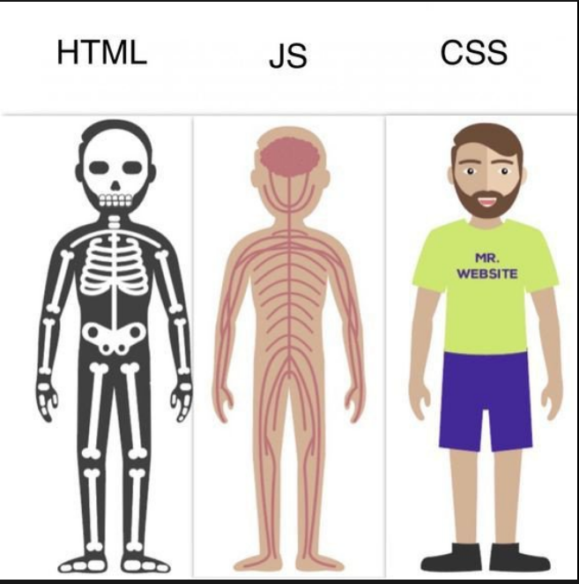

1. **Design Implementation**
   1. **Requirements Specification**

**Stake holders Identification**

**Primary Stakeholders** : Food nerds who are interested in trying to make different recipes in their

Kitchen are our primary stake holders.

**Secondary Stakeholders** : All family persons and people who consumes the recipe prepared falls under

secondary stakeholders

**Tertiary Stakeholders** : The shopkeepers, vendors and meat sellers fall under Tertiary stakeholders

as they indirectly get benefit from the primary stakeholders via food items.

**Facilitating Stakeholders** : We the developers, maintainers of the website and the video content

providers fall under facilitating stakeholders as they help us in improving

resources in our website.

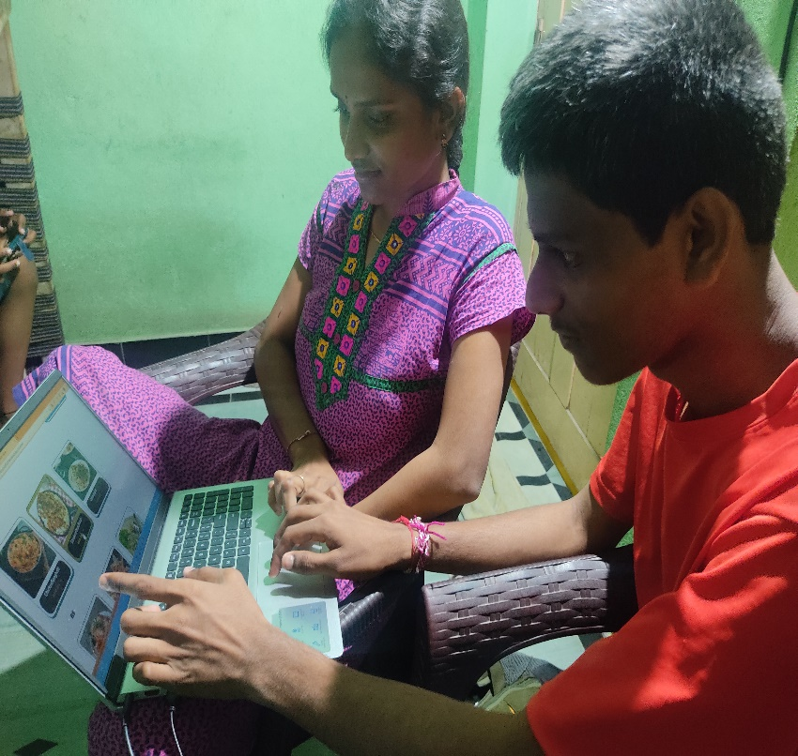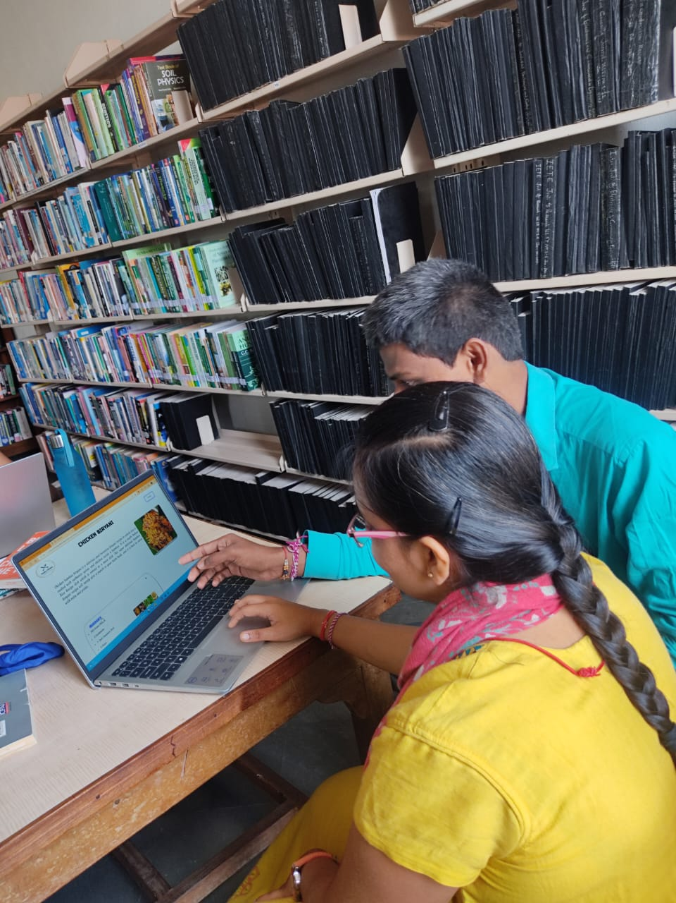

* 1. **Architectural Design**

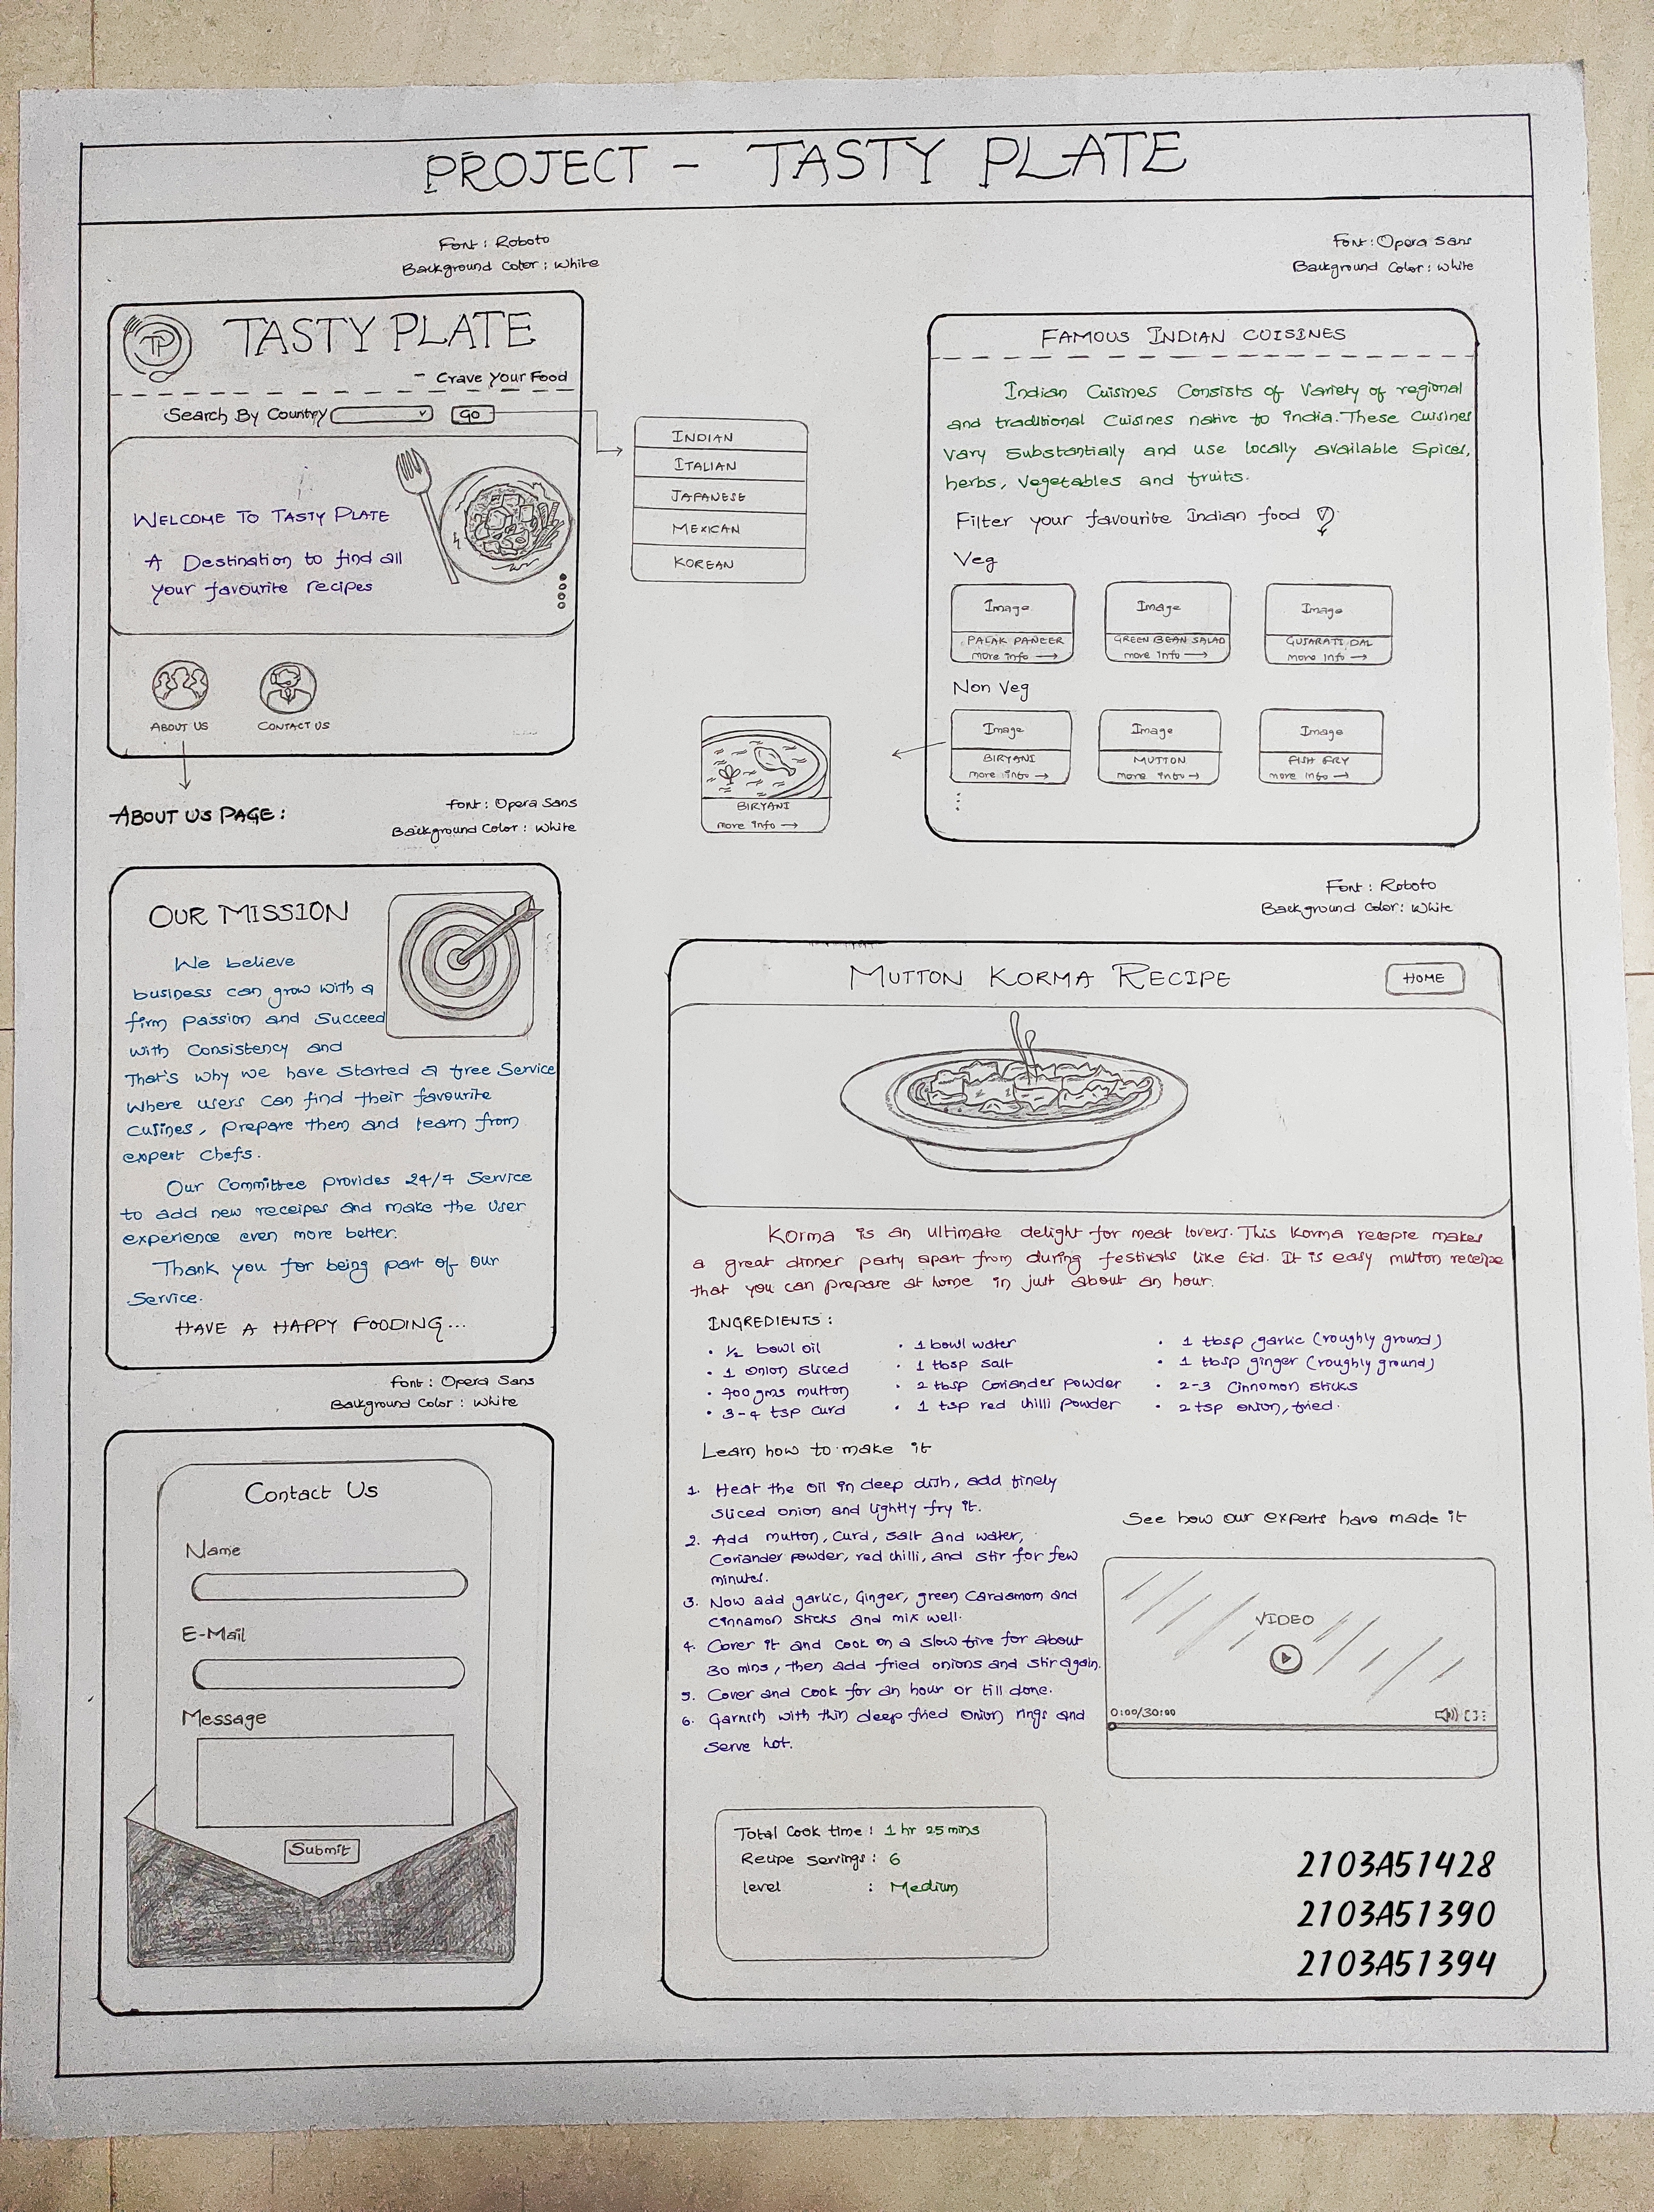

**Home Page**

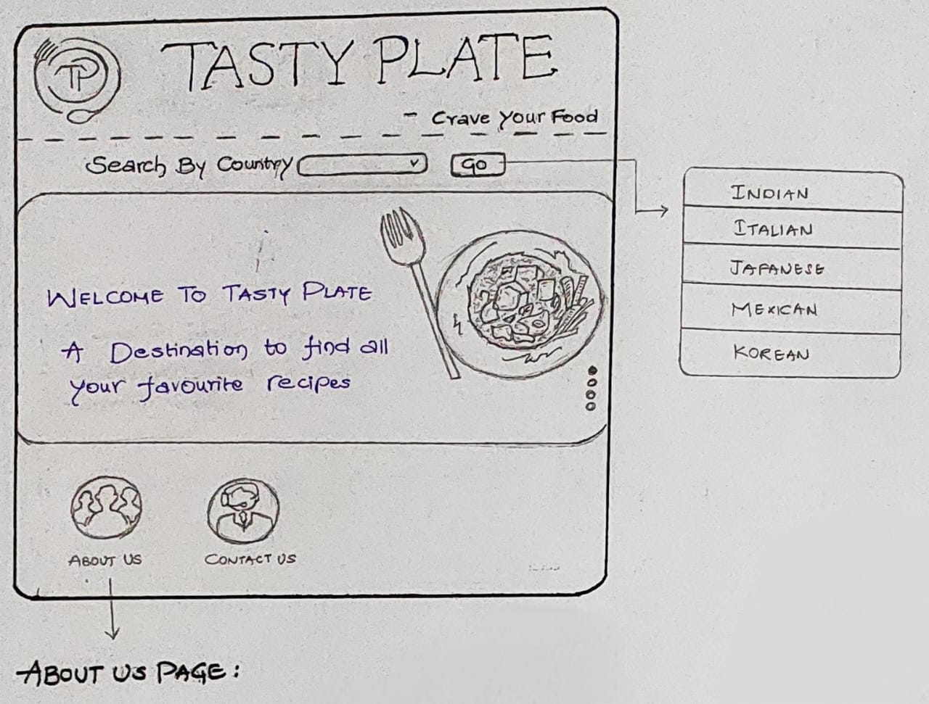

**Contact Us Page**

**About Us Page**

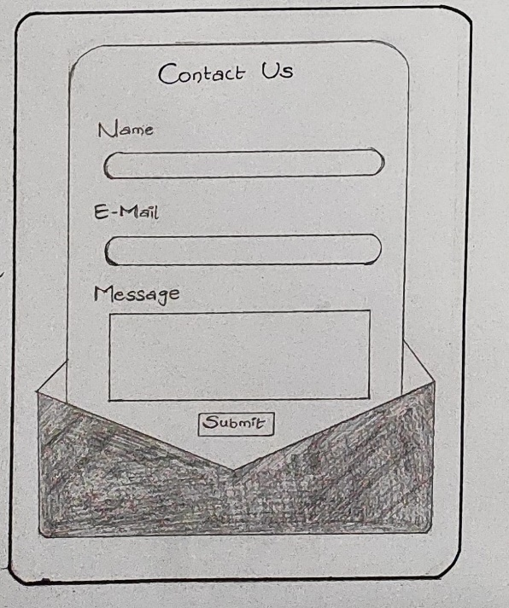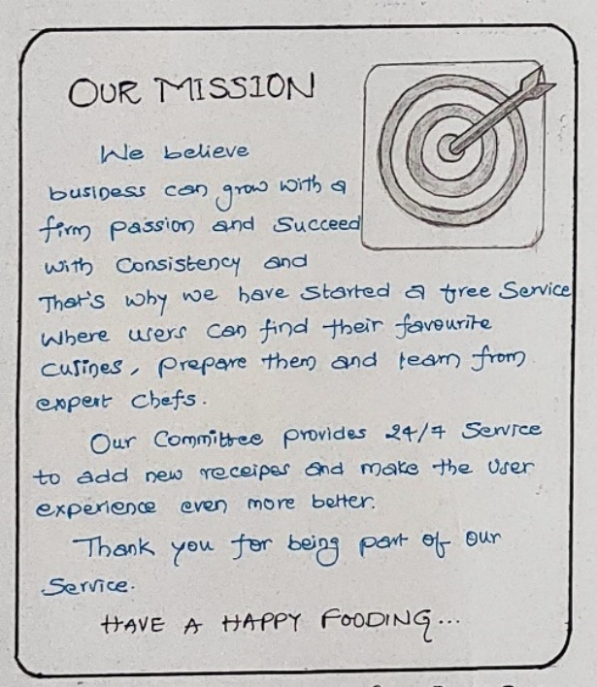

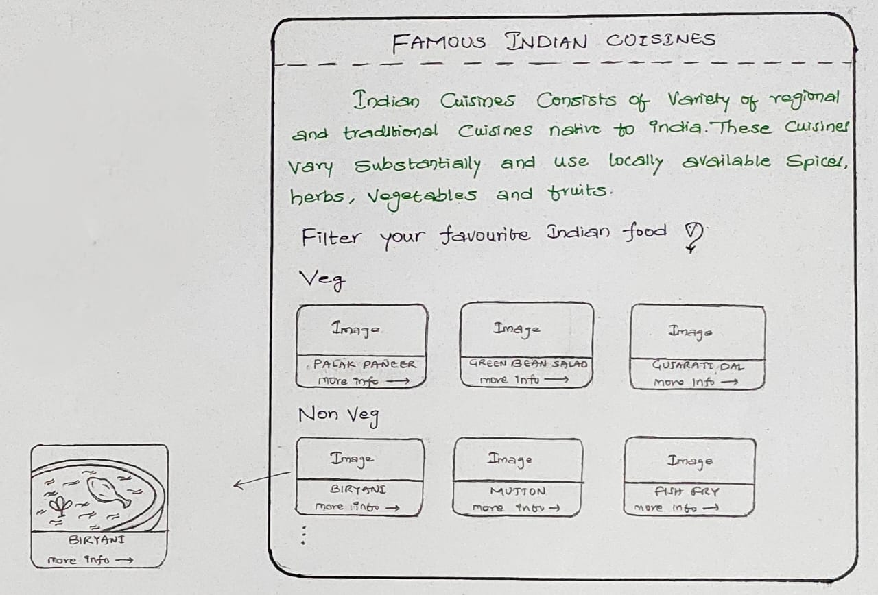

**Country Page**

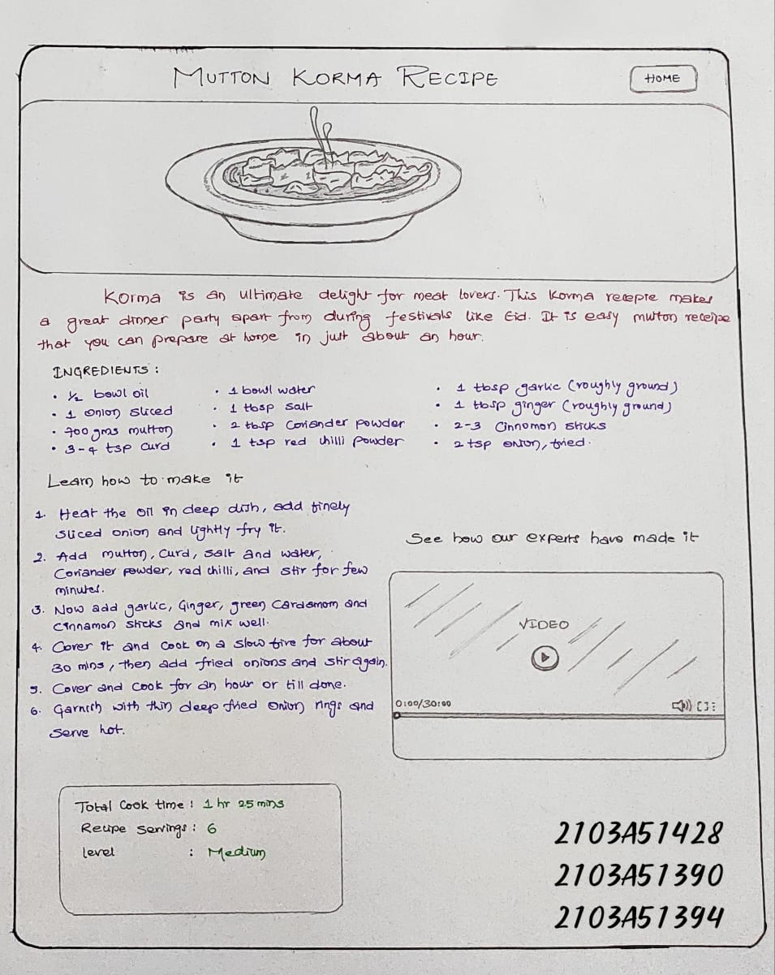

**Cuisine Page**

1. **IMPLEMENTATION**
   1. **Source Code**
2. **Main Home Page [HTML] Code**

|  |
| --- |
| <!DOCTYPE html>  <html lang="en">  <head>  <meta charset="UTF-8">  <meta http-equiv="X-UA-Compatible" content="IE=edge">  <meta name="viewport" content="width=device-width, initial-scale=1.0">  <title>Tasty Plate</title>  <script src="https://unpkg.com/ionicons@4.5.10-0/dist/ionicons.js"></script>  <link rel="preconnect" href="https://fonts.googleapis.com">  <link rel="preconnect" href="https://fonts.gstatic.com" crossorigin>  <link href="https://fonts.googleapis.com/css2?family=Courgette:wght@300;400&display=swap" rel="stylesheet">  <link href="https://fonts.googleapis.com/css2?family=Bangers:wght@300;400&display=swap" rel="stylesheet">  <link href="https://fonts.googleapis.com/css2?family=Kaushan Script:wght@300;400&display=swap" rel="stylesheet">  <link rel="stylesheet" href="https://cdn.jsdelivr.net/npm/swiper@8/swiper-bundle.min.css" />  <link rel="stylesheet" href="https://cdnjs.cloudflare.com/ajax/libs/font-awesome/4.7.0/css/font-awesome.min.css">  <link rel="stylesheet" href="./Main_home.css">  </head>  <body>  <div class="header">  <div class="logo">  <img src="./TP.jpg" class="logo-img">  </div>  <div class="title">  <label class="l1">Tasty Plate</label>  </div>  <div class="home-btn">  <button class="home" onclick="about_us()">About Us</button>  <button class="home1" onclick="contact_us()">Contact Us</button>  </div>  </div>  <div class="img-scroll-comp">  <!--NEXT IMAGE 1-->  <div class="banner1">  <img src=".indian.jpg" alt="">  <div class="text-box">  <h1>Indian Cusines</h1>  <span></span>  <p>Indian cuisine is known for its large assortment of dishes. The cooking style varies from region to  region and is largely divided into South Indian & North Indian cuisine. India is quite famous for  its diverse multi cuisine available in a large number of restaurants and hotel resorts, which is  reminiscent of unity in diversity.</p>  </div>  </div>  <!--Title Image-->  <div class="banner_main">  <img src="./TastyPlate.jpeg" alt="">  <div class="text-box">  <h1>Welcome to <br>Tasty Plate</h1>  <span></span>  <p>A destination guide for you to prepare various recipies across different countries. Explore differet  countries cuisines here and have a Happy Fooding!</p>  </div>  </div>  <!--NEXT IMAGE 1-->  <div class="banner01">  <img src="./indian.jpg" alt="">  <div class="text-box">  <h1>Indian Cuisines</h1>  <span></span>  <p>Indian cuisine is known for its large assortment of dishes. The cooking style varies from region to  region and is largely divided into South Indian & North Indian cuisine. India is quite famous for  its diverse multi cuisine available in a large number of restaurants and hotel resorts, which is  reminiscent of unity in diversity.<br>Explore Indian Cuisines here</p>  <button class="Explore" onclick="india_click()">Explore More</button>  </div>  </div>  <!--NEXT IMAGE 2-->  <div class="banner2">  <img src="./korean.jpg" alt="">  <div class="text-box">  <h1>Korean Cuisines</h1>  <span></span>  <p>Korean cuisine is largely based on rice, vegetables, seafood and (at least in South Korea) meats.  Dairy is largely absent from the traditional Korean diet. Traditional Korean meals are named for the  number of side dishes (반찬; 飯饌; banchan) that accompany steam-cooked short-grain rice.<br>Explore  Korean Cuisines here</p>  <button class="Explore" onclick="korea_click()">Explore More</button>  </div>  </div>  <!--NEXT IMAGE 3-->  <div class="banner3">  <img src="./italian.jpg" alt="">  <div class="text-box">  <h1>Italian Cuisines</h1>  <span></span>  <p>Italian cuisine (Italian: Cucina italiana, pronounced [ku'tʃi:na ita'lja:na]) is a Mediterranean  cuisine consisting of the ingredients, recipes and cooking techniques developed across the  Italian Peninsula since antiquity, and later spread around the world together with waves of Italian  diaspora  <br>Explore  Italian Cuisines here  </p>  <button class="Explore" onclick="italian_click()">Explore More</button>  </div>  </div>  <!--NEXT IMAGE 4-->  <div class="banner4">  <img src="./japnese.jpg" alt="">  <div class="text-box">  <h1>Japenese Cuisines</h1>  <span></span>  <p>Traditional Japanese cuisine is known as Washoku (meaning 'harmony' and ,to eat). Washok's  philosophy focuses on the harmony of ingredients that's both visually appealing and  nutritious.The traditional cuisine of Japan ( Japanese: washoku) is based on rice with miso soup and  other dishes; there is an emphasis on seasonal ingredients.<br>Explore  Japenese Cuisines here</p>  <button class="Explore" onclick="japnese_click()">Explore More</button>  </div>  </div>  <!--NEXT IMAGE 5-->  <div class="banner5">  <img src="./mexican.jpg" alt="">  <div class="text-box">  <h1>Mexican Cuisines</h1>  <span></span>  <p>To prepare most dishes, Mexicans use simple, hearty ingredients. Culinary experts note that a  characteristic feature of local gastronomy is the small number of components that are part of the  dishes, but chefs know “a thousand ways to combine them.”  Modern Mexicans reverently preserve their rich gastronomic heritage.<br>Explore  Mexican Cuisines here</p>  <button class="Explore" onclick="mexican_click()">Explore More</button>  </div>  </div>  </div>  <footer class="footer">  <div class="cross"></div>  <div class="footer0">  <h1>Tasty Plate</h1>  </div>  <div class="footer1 ">  Connect with us at  <div class="social-media">  <a href="https://www.facebook.com/beeraboina.shivakrishnayadav">  <ion-icon name="logo-facebook"></ion-icon>  </a>  <a href="https://www.linkedin.com/in/beeraboina-shiva-krishna-11a393226">  <ion-icon name="logo-linkedin"></ion-icon>  </a>  <a href="http://www.youtube.com/@shivakrishnabeeraboina6360">  <ion-icon name="logo-youtube"></ion-icon>  </a>  <a href="https://www.instagram.com/?hl=en">  <ion-icon name="logo-instagram"></ion-icon>  </a>  <a href="https://twitter.com/ShivaBeeraboina">  <ion-icon name="logo-twitter"></ion-icon>  </a>  </div>  </div>  </div>  <div class="footer3">Copyright © <h4>Tasty Plate</h4> 2022</div>  </footer>  <Script>  function about_us() {  window.open("./aboutus.html", "_self");  }  function contact_us() {  window.open("./contact-demo.html", "_self");  }  function india_click() {  window.open("./indian/indian_dishes.html", "_self");  }  function korea_click() {  window.open("./korean/koreandishes.html", "_self");  }  function italian_click() {  window.open("./Italian/italian_dishes.html", "_self");  }  function japnese_click() {  window.open("./japanese/japanesedishes.html", "_self");  }  function mexican_click() {  window.open("./mexican/mexican_dishes.html", "_self");  }  </Script>  </body>  </html> |

1. **Country Cuisines Page [HTML Code]**

|  |
| --- |
| <!DOCTYPE html>  <html lang="en">  <head>  <meta charset="UTF-8">  <meta http-equiv="X-UA-Compatible" content="IE=edge">  <meta name="viewport" content="width=device-width, initial-scale=1.0">  <title>Indian Cuisines</title>  <link rel="stylesheet" href="./indian_dishes.css">  <link rel="preconnect" href="https://fonts.googleapis.com">  <link rel="preconnect" href="https://fonts.gstatic.com" crossorigin>  <link href="https://fonts.googleapis.com/css2?family=Courgette:wght@300;400&display=swap" rel="stylesheet">  <link href="https://fonts.googleapis.com/css2?family=Bangers:wght@300;400&display=swap" rel="stylesheet">  <link href="https://fonts.googleapis.com/css2?family=Russo One:wght@300;400&display=swap" rel="stylesheet">  </head>  <body>  <div class="header">  <div class="logo">  <img src="Tp.jpg" class="logo-img">  </div>  <div class="title">  <h1>Indian Cuisines</h1>  </div>  <div class="home-btn">  <button class="home" onclick="home()">Home</button>  </div>  </div>  <div class="labels">  <h2 class="headings"> About Indian Cuisines</h2>  </div>  <div class="info-box">  <div class="info">  <label>India food like its culture is varied and is quite popular across the world. Indian food is the  blend  of varied herbs and species which make every dish quite unique and special. Thought most of the  countries  love Indian food, it is considered to be quite spicy when compared to other cuisines.<br>  Indian food is wide and includes a lot variety of variety. Each State of India has its own unique  cuisine that reflects culture and their tradition.</label>  </div>  <div class="india-img-card">  <img src="./indian-cuisine-bg.jpeg" class="info-img">  </div>  </div>  <div class="labels">  <h2 class="headings">Non-Veg</h2>  </div>  <div class="flex-box">  <div class="card">  <img src="./muttonkurma.jpeg" class="card-img" alt="">  <div class="action-link">  <label class="name-labels"><b>Mutton Kurma</b></label><br>  <a href="./mutton_kurma.html" class="label-links">more info <span  style="font-size:25px;">&rarr;</span></a>  </div>  </div>  <div class="card">  <img src="bamboochickenbiryani.jpg" class="card-img" alt="">  <div class="action-link">  <label class="name-labels"><b>Chicken Biryani</b></label><br>  <a href="bamboochickenbiryani.html" class="label-links">more info <span  style="font-size:25px;">&rarr;</span></a>  </div>  </div>  <div class="card">  <img src="chickentikka.jpeg" class="card-img" alt="">  <div class="action-link">  <label class="name-labels"><b>Chicken Tikka</b></label><br>  <a href="chickentikka.html" class="label-links">more info <span  style="font-size:25px;">&rarr;</span></a>  </div>  </div>  </div>  <div class="labels">  <h2 class="headings">Veg</h2>  </div>  <div class="flex-box">  <div class="card">  <img src="paneerbuttermasala.jpeg" class="card-img" alt="">  <div class="action-link">  <label class="name-labels"><b>Shahi Paneer</b></label><br>  <a href="paneerbuttermasala.html" class="label-links">more info <span  style="font-size:25px;">&rarr;</span></a>  </div>  </div>  <div class="card">  <img src="pavbhaji.jpeg" class="card-img" alt="">  <div class="action-link">  <label class="name-labels"><b>Pav Bhaji</b></label><br>  <a href="pavbhaji.html" class="label-links">more info <span style="font-size:25px;">&rarr;</span></a>  </div>  </div>  <div class="card">  <img src="vegbiryani.jpeg" class="card-img" alt="">  <div class="action-link">  <label class="name-labels"><b>Veg Biryani</b></label><br>  <a href="vegbiryani.html" class="label-links">more info <span style="font-size:25px;">&rarr;</span></a>  </div>  </div>  </div>  <div class="labels">  <h2 class="headings">Break Fast</h2>  </div>  <div class="flex-box">  <div class="card">  <img src="dosa.jpeg" class="card-img" alt="">  <div class="action-link">  <label class="name-labels"><b>Dosa</b></label><br>  <a href="dosa.html" class="label-links">more info <span style="font-size:25px;">&rarr;</span></a>  </div>  </div>  <div class="card">  <img src="puri.jpeg" class="card-img" alt="">  <div class="action-link">  <label class="name-labels"><b>Puri</b></label><br>  <a href="puri.html" class="label-links">more info <span style="font-size:25px;">&rarr;</span></a>  </div>  </div>  <div class="card">  <img src="paratha.jpeg" class="card-img" alt="">  <div class="action-link">  <label class="name-labels"><b>Paratha</b></label><br>  <a href="paratha.html" class="label-links">more info <span style="font-size:25px;">&rarr;</span></a>  </div>  </div>  </div>  <div class="bottom-nav">  <div class="main"><a href="./indian_dishes.html" class="back">Back to Top &#8593;</a> </div>  </div>  <script>  function home() {  window.open("../Main_home.html", "_self");  }  </script>  </body>  </html> |

1. **Cuisine Page [HTML CODE]**

|  |
| --- |
| <!DOCTYPE html>  <html lang="en">  <head>  <meta charset="UTF-8">  <meta http-equiv="X-UA-Compatible" content="IE=edge">  <meta name="viewport" content="width=device-width, initial-scale=1.0">  <link rel="preconnect" href="https://fonts.googleapis.com">  <link rel="preconnect" href="https://fonts.gstatic.com" crossorigin>  <link href="https://fonts.googleapis.com/css2?family=Courgette:wght@300;400&display=swap" rel="stylesheet">  <link href="https://fonts.googleapis.com/css2?family=Bangers:wght@300;400&display=swap" rel="stylesheet">  <link href="https://fonts.googleapis.com/css2?family=Russo One:wght@300;400&display=swap" rel="stylesheet">  <link rel="stylesheet" href="./mutton_kurma.css">  <title>Document</title>  </head>  <body>  <div class="header">  <div class="logo">  <img src="./Tp.jpg" class="logo-img">  </div>  <div class="title">  <h1>Mutton Kurma</h1>  </div>  <div class="home-btn">  <button class="home" onclick="home()">Home</button>  </div>  </div>  <div class="info-box">  <div class="info">  <label>Mutton Korma is one of the best mutton recipes to try. It is cherished as an authentic  Lucknowi/Awadhi dish which is rich and full of flavors. Not to mention that it was loved by Mughal  rulers as well. Mutton Korma is a popular mutton curry from North India and belongs to the Awadhi  cuisine.  Most popularly made in Lucknow, the base of this curry is made with whole spices, cashew nuts, fried  onions, yogurt, and everyday spices.</label>  </div>  <div class="india-img-card">  <img src="./muttonkurma.jpeg" class="info-img">  </div>  <!-- <div class="info2">  <label>  Kewra is used extensively in Mughlai cooking and gives a very characteristic aftertaste to the Biryanis  and Kormas. Every time you eat Mutton Korma, you feel a melange of rich complex flavors on your palate.  If you have any special occasion coming or want to make something royal and rich for your weekend, do  make this Mutton Korma recipe.</label>  </div> -->  </div>  <div>  <nav class="navv1">  <labelfor="touch"><span class="span1">Ingredients</span></label>  <input type="checkbox" id="touch">  <div class="slide">  <ul>  <div class="ing-list">  <li>1/2 bowl oil </li>  <li>1 Onion(Sliced)</li>  <li>700 gms mutton</li>  <li>3-4 teaspoon Curd</li>  <li>1 bowl Water</li>  <li>1 teaspoon Salt</li>  <li>2 teaspoon Coriander Powder</li>  <li>1 teaspoon Red Chilli Powder</li>  <li>1 teaspoon Garlic(roughly grounded)</li>  <li>1 teaspoon Ginger(roughly grounded)</li>  <li>3-4 Cloves</li>  <li>2-3 Whole Green Cardamom</li>  <li>2-3 Cinnamon Sticks</li>  <li>2 teaspoon Onions(fried)</li>  </div>  </ul>  <div class="college-img">  <img src="mutton-kurma-college.jpeg" class="college-img-det">  </div>  </div>  </nav>  <nav class="navv-ing">  <label for="touch-ing"><span class="span-ing">Nutrition Facts</span></label>  <input type="checkbox" id="touch-ing">  <div class="slide-ing">  <ul>  <div class="ing-list">  <li>Calories 267</li>  <li>Total Fat 6.27g(8%)</li>  <li>Cholesterol 38mg(13%)</li>  <li>Sodium 998mg(43%)</li>  <li>Total Carbohydrate 35.13g(13%)</li>  <li>Vitamin C 32.3mg(36%)</li>  <li>Vitamin A 35mcg(4%)</li>  </div>  </ul>  </div>  </nav>  <nav class="navv2">  <labelfor="touch2"><span class="span2">Procedure</span></label>  <input type="checkbox" id="touch2">  <div class="slide2">  <ol>  <li>Heat the oil in a deep dish, add the finely sliced Onions and lightly fry it. </li>  <hr>  <li>Add the mutton, curd, salt, water, coriander powder, red chilli powder and stir for a few  minutes.  </li>  <hr>  <li>Now add the garlic, ginger, cloves, green cardamom and the cinnamon sticks and mix well.</li>  <hr>  <li>Cover it and cook on a slow fire for about 30 mins, then add the fried onions and stir again.  </li>  <hr>  <li>Cover and cook for an hour or till done.</li>  <hr>  <li>Garnish with thin deep fried onion rings and serve hot.</li>  <hr>  </ol>  </div>  </nav>  <nav class="navv3">  <label for="touch3"><span class="span3">Expert Guide</span></label>  <input type="checkbox" id="touch3">  <div class="slide3">  <iframe class="video" src="https://www.youtube.com/embed/KxNqKJJSEhg?controls=1"></iframe>  </div>  </nav>  <div class="flex-bottom">  <div class="bottom-nav">  <div class="main"><a href="./indian_dishes.html" class="back">Back &#8592;</a> </div>  </div>  <div class="bottom-nav">  <div class="main2"><a href="./mutton_kurma.html" class="back2">Scroll to Top &#8593;</a> </div>  </div>  </div>  <script>  function home() {  window.open("../Main_home.html", "_Self");  }  </script>  </body>  </html> |

1. **RESULTS SCREENS**
2. **Main Home Page**

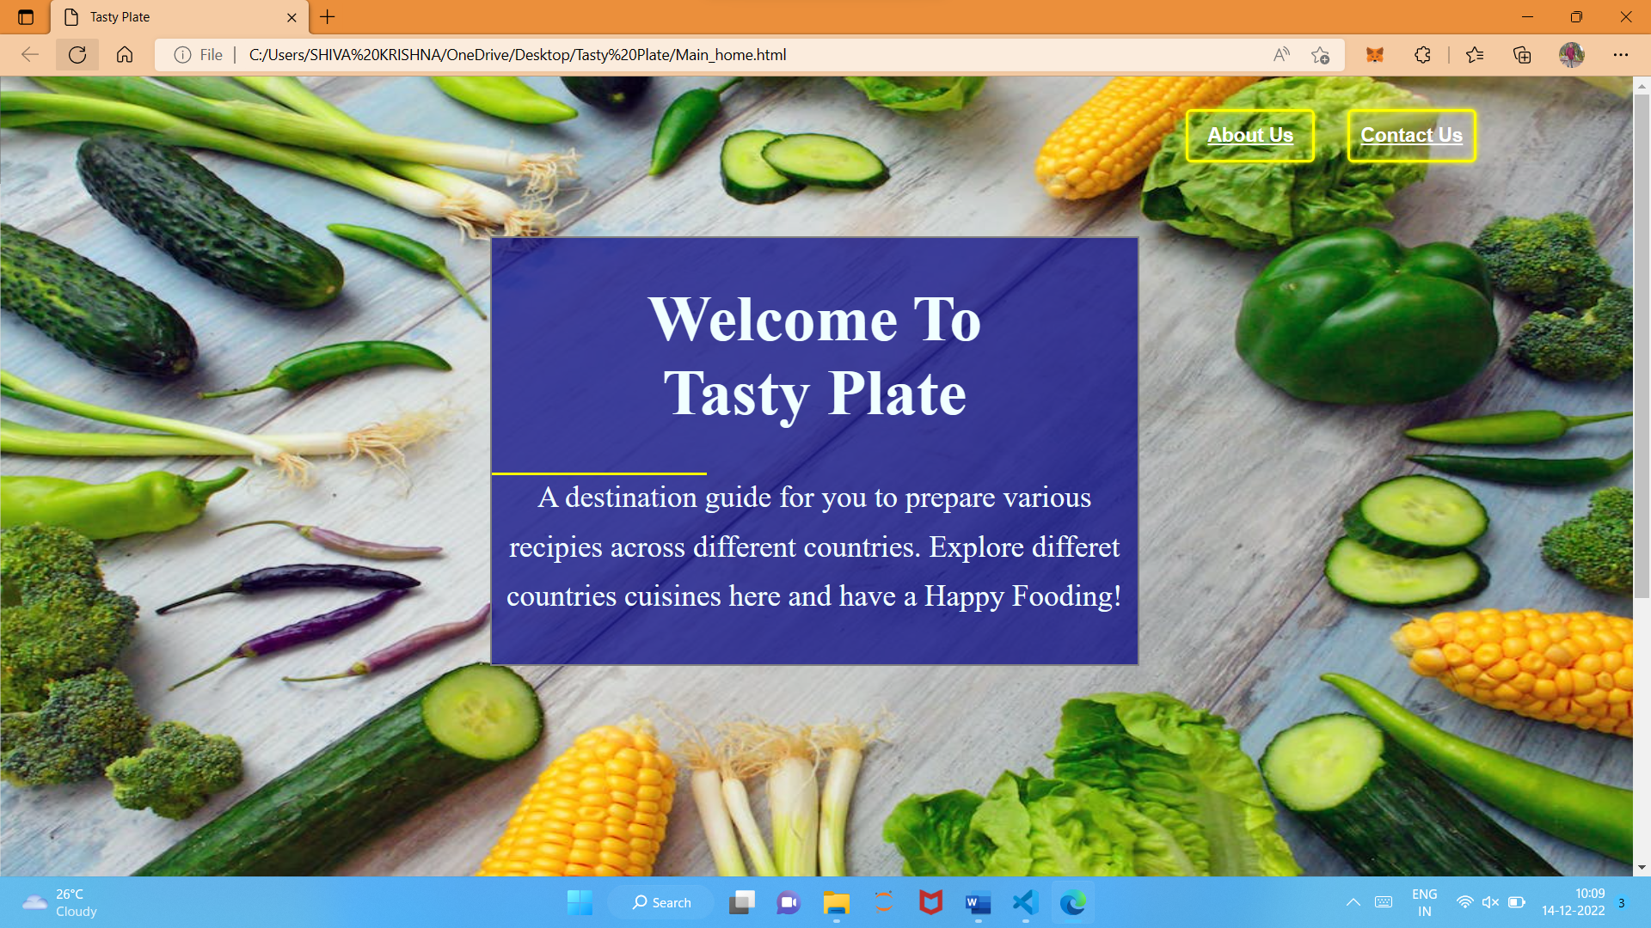

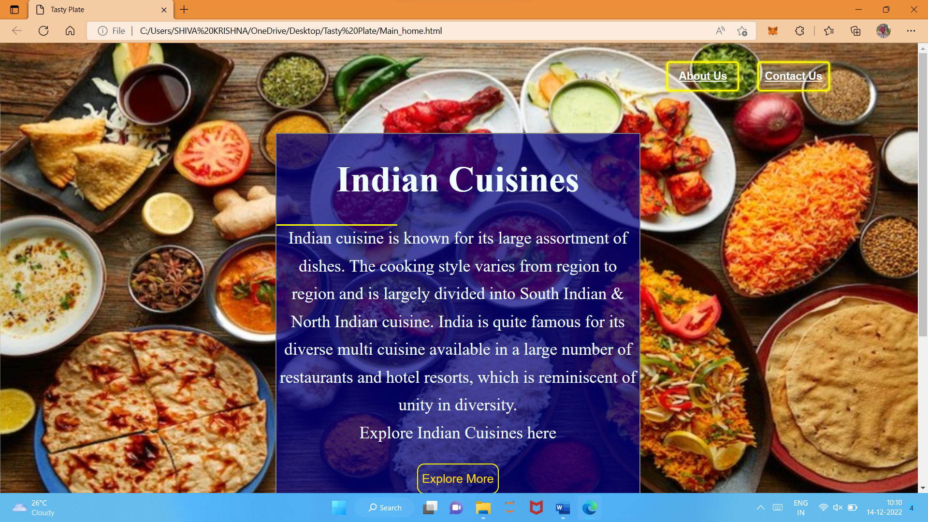

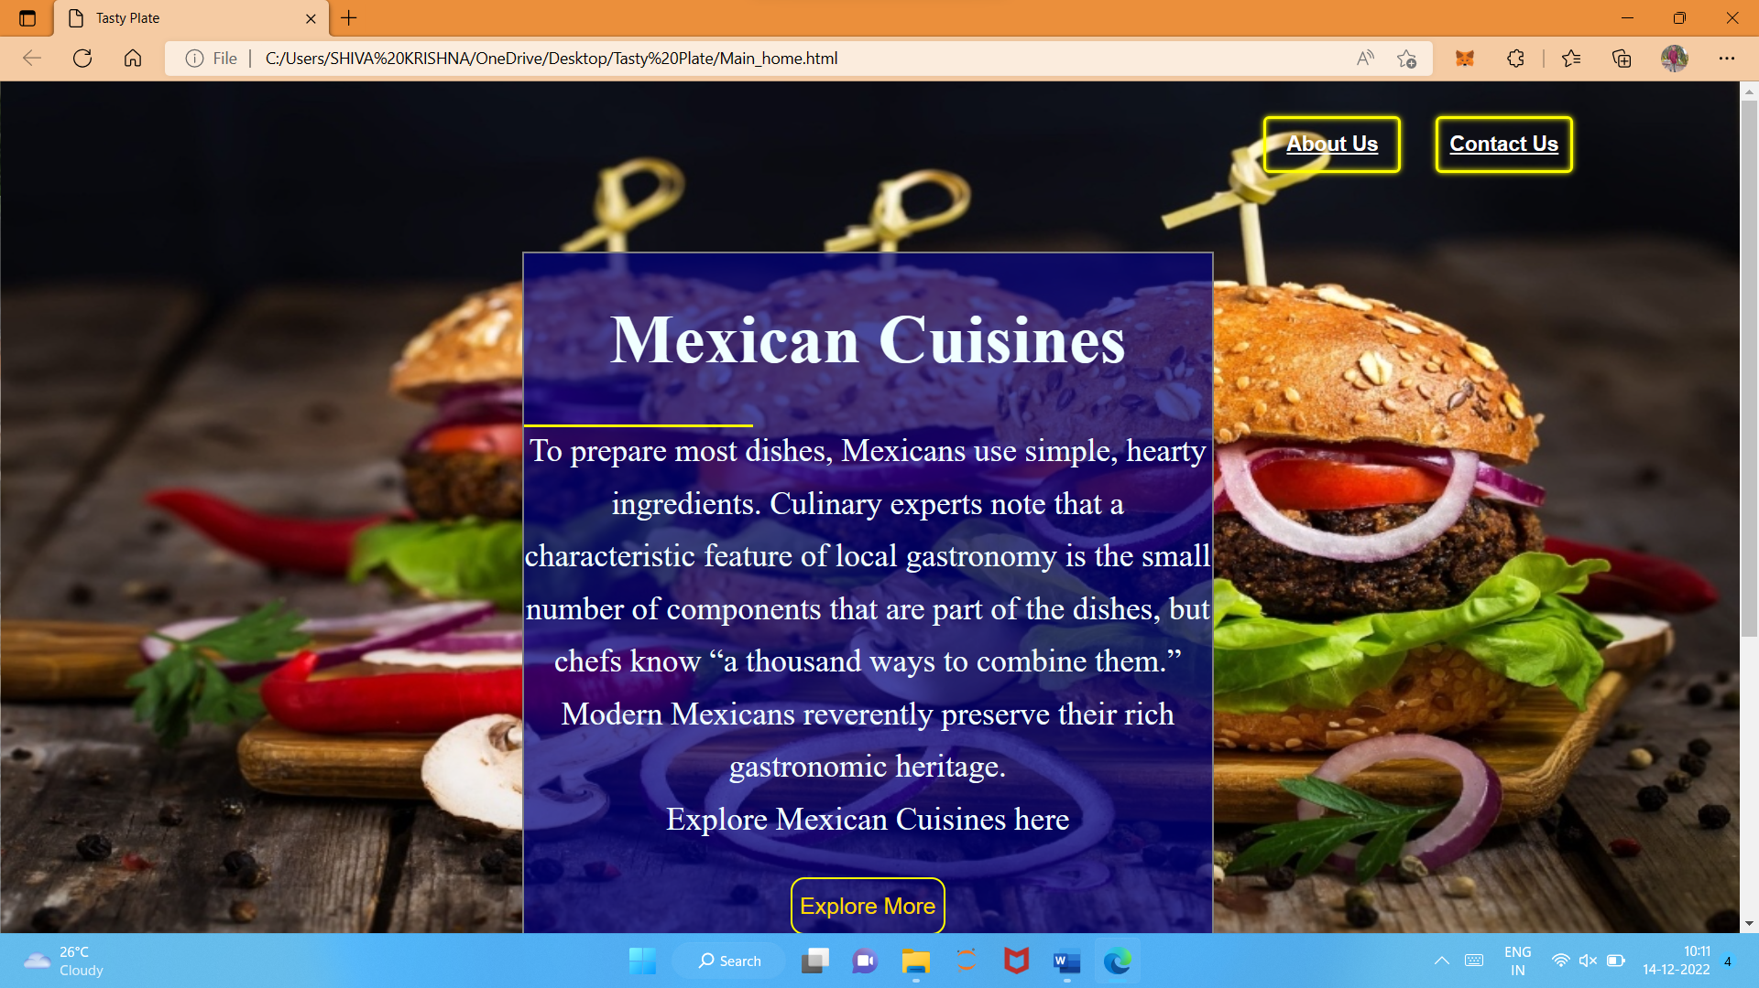

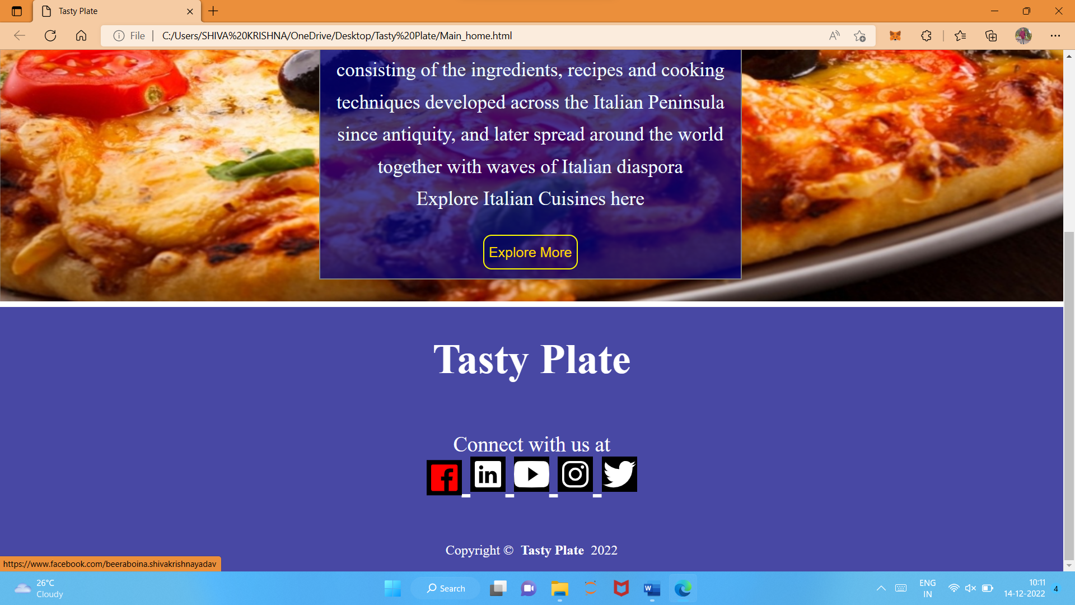

1. **Country Cuisine Page Screens**

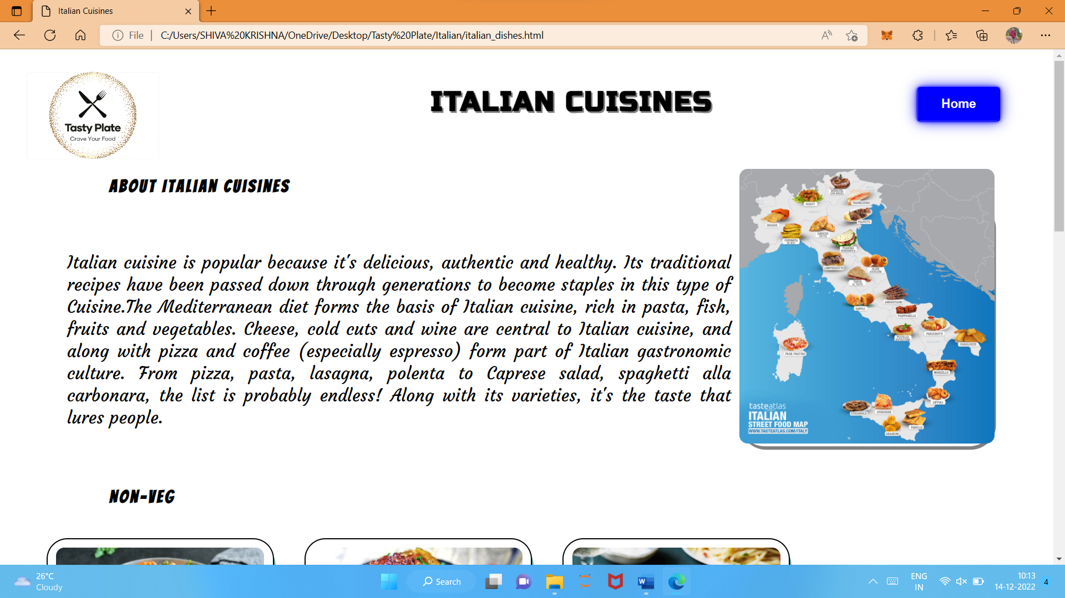

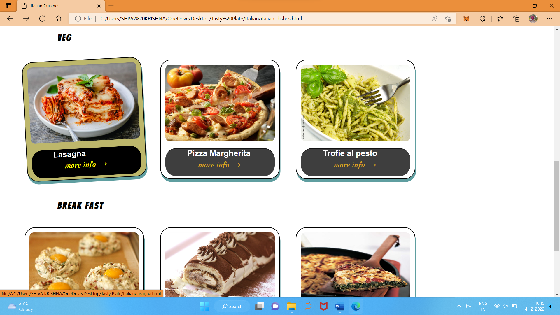

1. **Cuisine Page Screens**

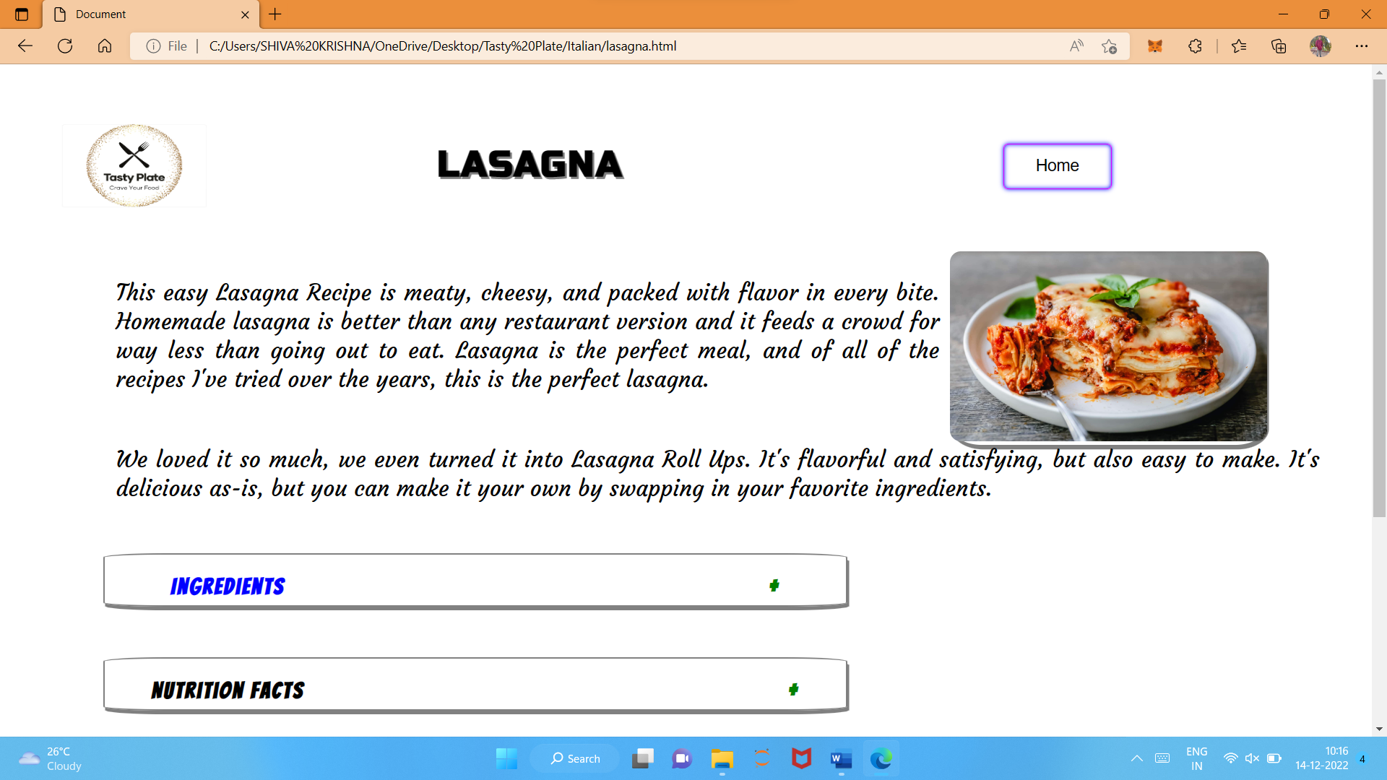

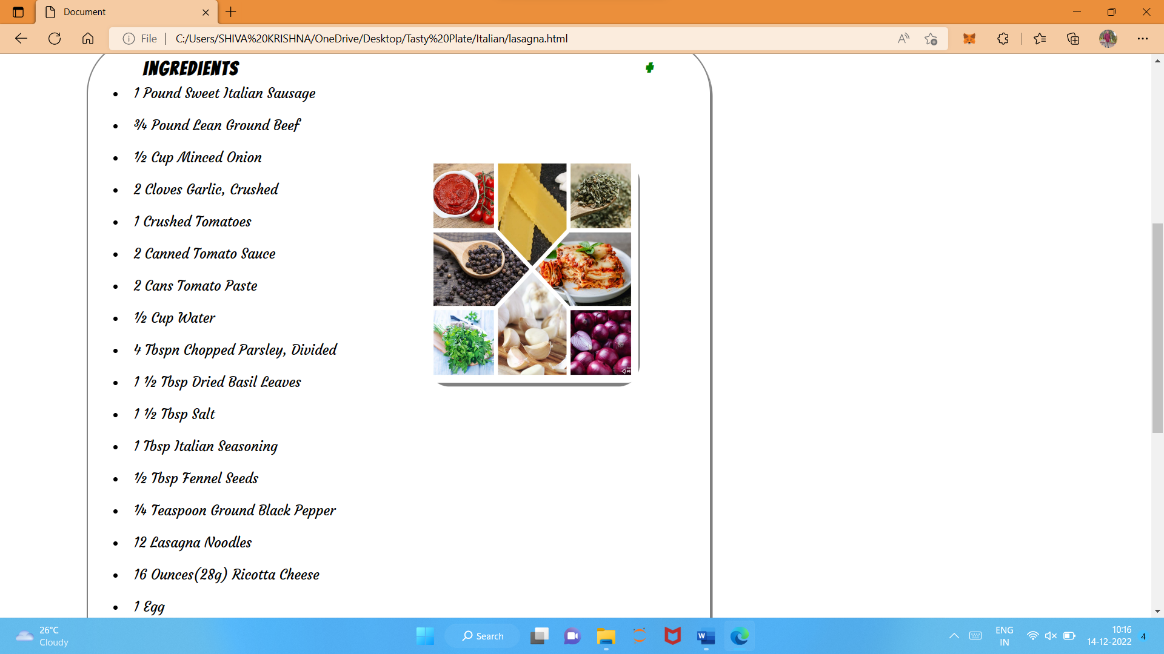

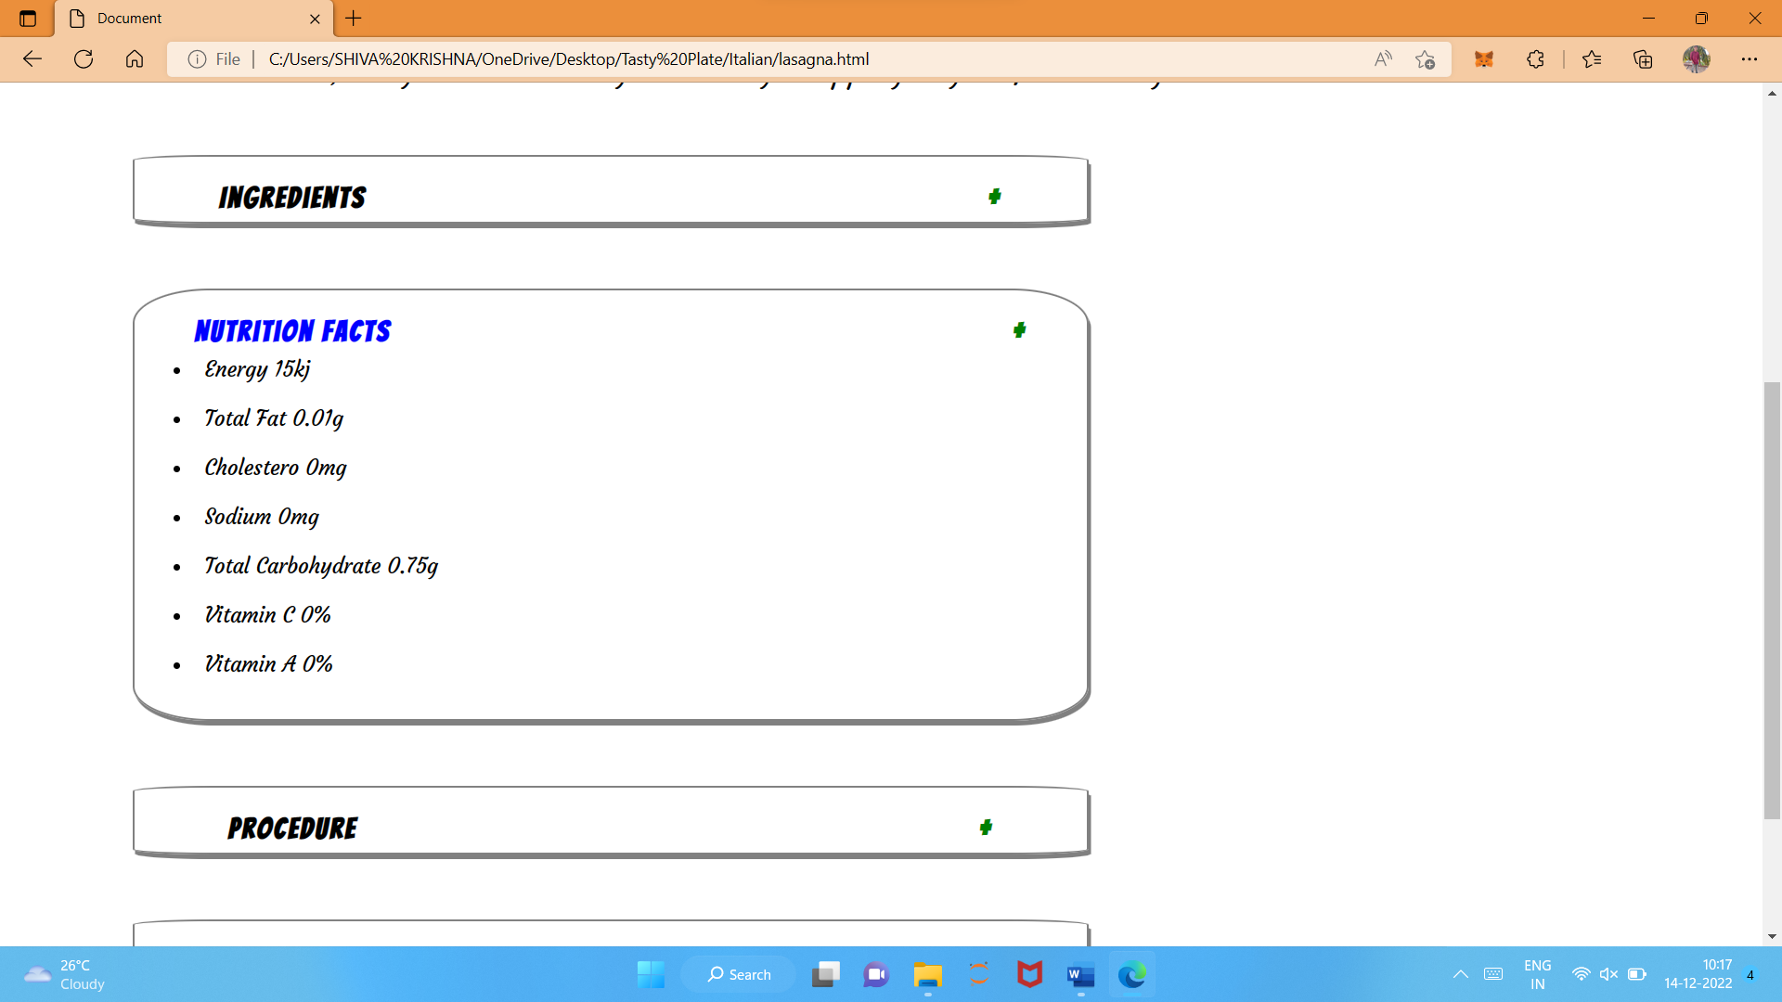

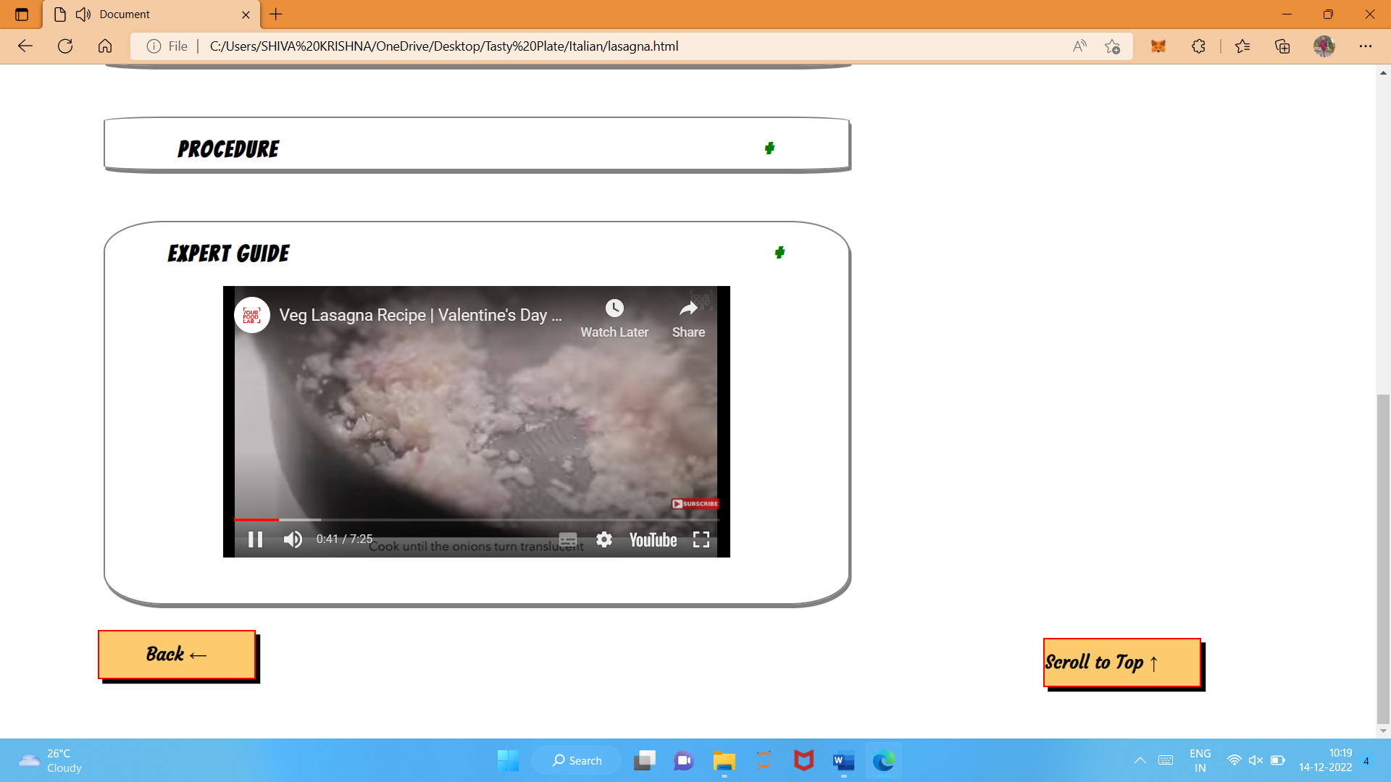

1. **About Us Page Screens**

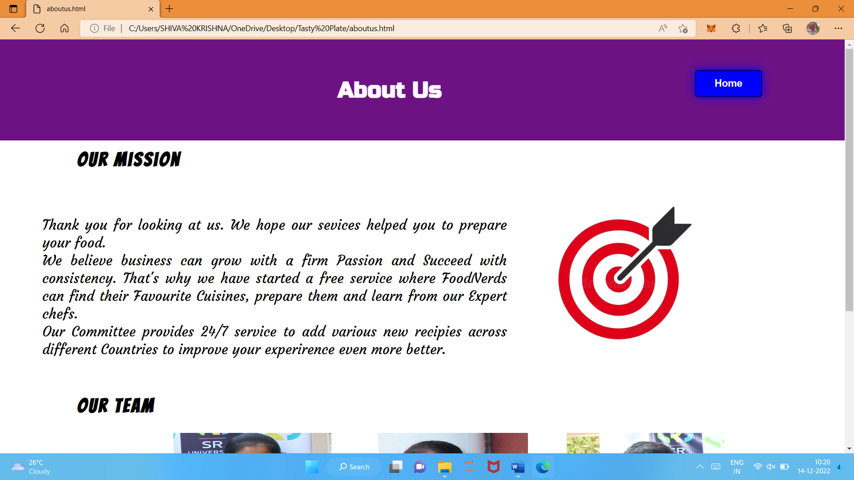

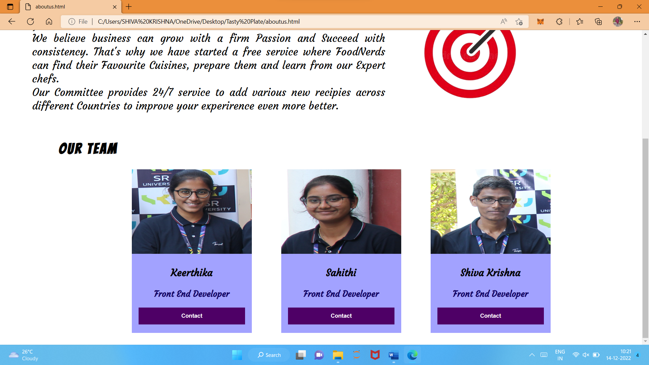

1. **Contact Us Page Screens**

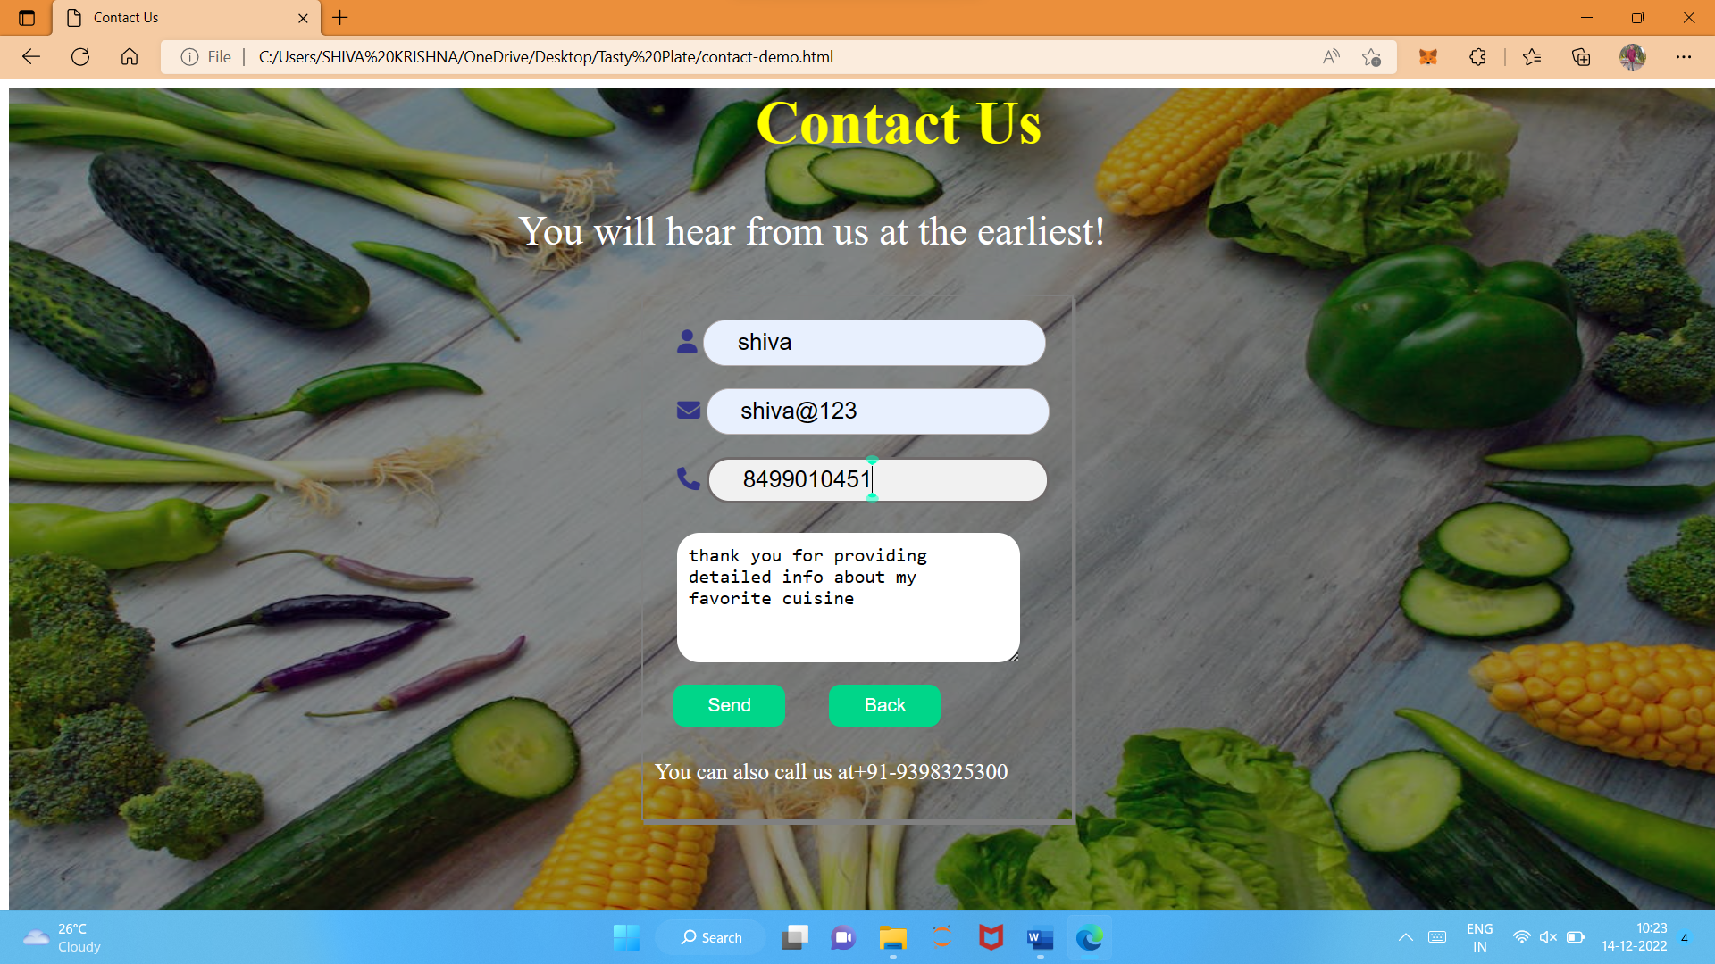

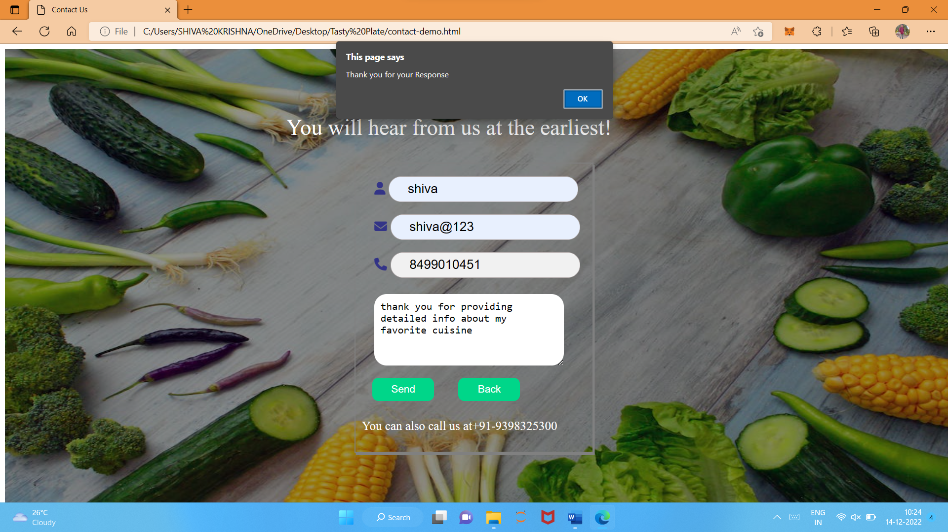

1. **CONCLUSION**

The main purpose of our website is making an attempt to enable people to cook effortlessly without getting stressed. Our website is very useful for the one who is crazy about making their food and trying out something new. Our website doesn’t stop with local foods of one particular country but explores with the top five most delicious food recipes from different countries. If they find it difficult to cook by the provided recipe, they can watch the video which was provided in the website. And it also very user friendly which makes it easy for the users to operate the website and can easily navigate within the website.

In future, we wish to provide 24/7 service to add new recipes and make the user experience even better. We can also make partnership with chefs to provide live videos for the users for good experience.